**P/N: SCA-VSK-50E**

|  |
| --- |
|  |
| A 7 pin suzi cable kit to enable installation of two cameras (Select) and monitor set up to an articulated vehicle. |

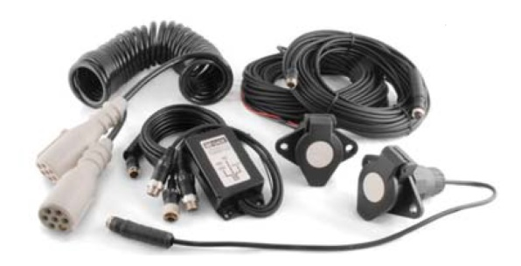

|  |  |
| --- | --- |
| Components | 7 pin bulkhead socket for cab, with 2 replicated camera connections |
|  | 7 pin bulkhead socket for trailer, with 2 connections for camera |
|  | Coiled 7 pin interconnecting cable |
|  | 2 x 20m cable |
|  | 1 x 5m cable |
|  | Two way camera selector |
|  |  |
| Connection | 4 Pin Aviation |
| Length | Max 4.5m |

|  |  |  |  |  |  |  |
| --- | --- | --- | --- | --- | --- | --- |
| A division of HANDSFREE GROUP, LUMSDALE ROAD, COBRA COURT, TRAFFORD PARK, MANCHESTER, M32 0UT  t. +44 (0) 161 864 6440 f. +44 (0) 161 865 8924 e. sales@ handsfree.co.uk w. www.handsfree.co.uk  Company Registration No: 5519584 VAT No. 834 5512 33 | | **Author:** | Dee Keenan | | **Date:** | 11/07/16 |
| **File name:** | Word document: PDF document: | HFw-VSK-50E.doc HFw-VSK-50E.pdf | | |
|  | | | | |
| **Version** | **Date** | Comments | | | | |
| 1.0 | 11/07/16 | Original documentation. | | | | |